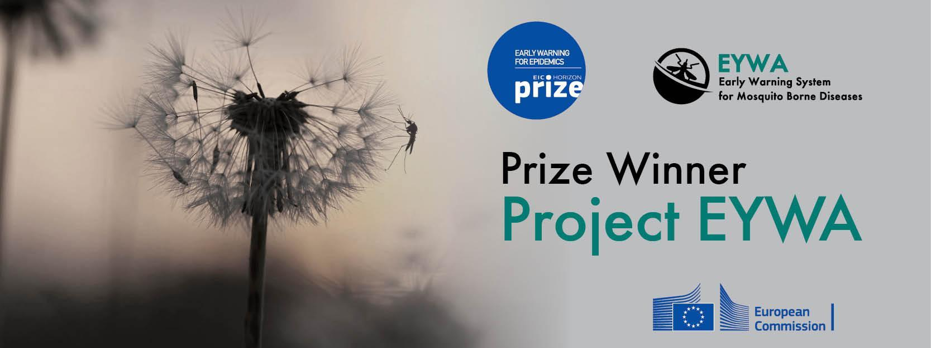

**Vojvodina Region, Serbia**

Report period 01/10/2024 - 31/10/2024

**EYWA** (EarlY WArning System for Mosquito-Borne Diseases), a prototype operational system since 2020, addressing the critical public health need for prevention and protection against the Mosquito-Borne Diseases (MBDs).

A game changer in the domain of epidemics that lies under the umbrella of **EuroGEO Action Group** "Earth Observation for Epidemics of Vector-borne Diseases - EO4EViDence"

This monthly Report is produced by the EYWA Project with key contributions in data and scientific expertise from its collaborating partners University of Novi Sad/Faculty of Agriculture/Laboratory for Medical and Veterinary Entomology, University of Novi Sad/Faculty of Medicine and Scientific Veterinary Institute "Novi Sad".

**Contents**

**INTRODUCTION** **4**

**PREDICTIVE MODELS** **6**

**1.** **MAMOTH – Mosquitoes Abundance model** **6**

*Culex* mosquitoes abundance prediction  6

**2. MIMESIS – HUMAN CASES RISK MODEL 8**

# Introduction

More than 80% of the global population lives in areas at risk of at least one major Vector-Borne Disease (VBD), with more than 700.000 deaths at a global scale. Mosquitoes are the protagonists of these vectors, carrying pathogens and transmitting various diseases to living beings and especially humans. Although specific actions and practices were adopted to control these diseases in Europe in the past decades, the re-emergence of outbreaks is just around the corner. Europe is experiencing an increasing number of human cases of Mosquito-Borne Diseases (MBD) in the last two decades, such as West Nile Virus (WVN), Malaria, Chikungunya, Dengue and Zika, both imported and indigenous, which demonstrates that Europe is not immune from MBD.

Serbia did not experience a WNV outbreak until 2009, when horses located in Vojvodina Province and the City of Belgrade of northern Serbia were tested positive for WNV. Surveillance of WNV in humans and mosquitoes was carried out from 2005 to 2010 in Vojvodina Province and showed presence and active circulation of WNV. National surveillance of WNF in humans began in 2012. Since then, WNF is endemo-epidemic in Serbia and has been registered every year (except 2020), with peaks recorded in 2013, 2018 and 2022. Specifically in 2018, Serbia was hit by the WNV outbreak reporting 415 human cases, with almost half of cases recorded in Vojvodina.

*Table 1.* West Nile fever in the human population, Serbia, 2010-2022.

|  |  |  |  |  |  |  |  |  |  |  |  |  |  |
| --- | --- | --- | --- | --- | --- | --- | --- | --- | --- | --- | --- | --- | --- |
| Year | 2010 | 2011 | 2012 | 2013 | 2014 | 2015 | 2016 | 2017 | 2018 | 2019 | 2020 | 2021 | 2022 |
| Number of cases | 0 | 0 | 71 | 303 | 77 | 30 | 43 | 49 | 415 | 44 | 0 | 18 | 246 |
| Incidence per 100.000 population | 0,0 | 0,0 | 0,9 | 3,4 | 1,1 | 0,4 | 0,6 | 0,7 | 5,8 | 0,6 | 0,0 | 0,3 | 3,6 |
| Autonomous Province of Vojvodina | | | | | | | | | | | | | |
| Number of cases | 0 | 0 | 16 | 90 | 23 | 9 | 14 | 9 | 192 | 14 | 0 | 13 | 68 |
| Incidence per 100.000 population | 0,0 | 0,0 | 0,8 | 4,7 | 1,2 | 0,4 | 0,7 | 0,5 | 9,9 | 0,7 | 0,0 | 0,7 | 3,7 |

EYWA is a revolutionary, scalable and sustainable EarlY WArning System for Mosquito-Borne Diseases and a game changer in the domain of epidemics. It was developed under the flag of EuroGEO Action Group “Earth Observation for Epidemics of Vector-Borne Diseases-EO4EViDence".

The system is based on a plethora of satellite Earth Observation (environmental, meteorological, geomorphological etc.), in-situ entomological networks, epidemiological and crowdsourcing data. These Big Data are combined with mathematical modelling, artificial intelligence, and state-of-the-art technological tools. The system’s models provide mosquitoes’ population abundance and human cases risk predictions, at trap, settlement and municipality level accordingly.

In recognition of the advances made by the system in providing early warning, EYWA was awarded the 1st EIC Horizon Prize on Early Warning for Epidemics.

EYWA was pre-operationally tested in Vojvodina region in Serbia, forecasting *Culex* mosquito populations, during the mosquito season in 2020, and provided operational predictions for the years 2021, 2022 & 2023.

EYWA continues its operation in 2024, informing the local authorities and decision makers about *Culex* mosquitoes’ abundance.

# Predictive models

The results of the “MAMOTH” data-driven mosquitoes’ abundance model for the period **08/10/2024 – 23/10/2024**, and of the “MIMESIS” dynamic human cases risk model for the period **25/09/2024 – 25/10/2024**, are presented in the following sections.

## MAMOTH – Mosquitoes’ Abundance model

The “MAMOTH” data-driven mosquitoes’ abundance predictive model has been in operational use since 2020. The model is able to predict the risk classes of mosquitoes’ population.

For each entomological record, the respective EO environmental and meteorological data (NDVI, NDWI, NDMI, NDBI, Land Surface Temperature, rainfall and wind), and geomorphological data (land use, aspect, elevation etc.) have been extracted from Sentinel-2, Landsat-7 & -8, MODIS, and ERA-5 to create the comprehensive feature space.

The abundance of the mosquitoes has been classified into 10 risk classes starting from 0 indicating the lower class of mosquito presence reaching the higher class 9, with each one having equal probability of selection. A XGBoost model is trained for this task, and a certain pipeline is followed. The multi-source dataset mentioned above, underwent spatial and temporal integration, as well as feature engineering that has been applied to further extend the initial dataset through new informative features that capture the spatio-temporal dependencies of the problem. Through an automated process the model can tune its own parameters and select the most important features out of a pool of potential features in each case in order to better fit the dataset, and achieve higher prediction performance.

### *Culex* mosquitoes’ abundance prediction

The forecast model is based on time series entomological data for the period of 2010-2023. The dataset has been gathered from CO2 and gravid traps, there were used to lure and sample adult mosquitoes from 124 stations distributed among the Vojvodina region. The data consist of 6756 records and represent the number of mosquitoes and the date of trap placement.

#### Risk classes

Table 2 shows the classes of the mosquito abundance and the bounds (range) of mosquito’ numbers per each class.

Table 2*: Bounds of Culex mosquito risk classes.*

|  |  |  |
| --- | --- | --- |
| Class | Number of mosquitoes | Risk class |
| 0 | 0 - 9 | low |
| 1 | 10 - 27 |
| 2 | 28 - 56 | medium |
| 3 | 57 - 101 |
| 4 | 102 - 172 |
| 5 | 173 - 212 |
| 6 | 213 - 356 | high |
| 7 | 357 - 568 |
| 8 | 569 - 1070 |
| 9 | > 1070 |

#### Reliability of the model

The model has been trained and tested on 10-fold validation data. The trained model outperforms statistically with an expected mean absolute error of **1.54** classes between the actual and the predictive value. Furthermore, the model proves its robustness by capturing the low, medium and high-risk classes of mosquito population with a predictive accuracy of **93%.**

#### Prediction

The predictions of the model are presented in the map of Figure 1, which depicts the predicted trap – stations for October 2024 in the Vojvodina region ranging from traps colored in blue, stations that the model predicts lower risk class of the *Culex* population, to traps colored in red indicating stations with prediction of higher risk class in mosquito abundance. The predictions for October 2024 showed that the stations in the Vojvodina region will fall into **low % medium risk classes** ranging from risk class 0 to risk class 4. In further detail:

* 1994 stations were predicted with risk classes 0 & 1, indicating low abundance of mosquitoes (0 – 27).
* 3722 stations were predicted with risk classes 2-4, indicating medium abundance of mosquitoes (28 – 172).

Εικόνα που περιέχει κείμενο, χάρτης, στιγμιότυπο οθόνης

Περιγραφή που δημιουργήθηκε αυτόματα

*Figure 1. Culex mosquito abundance at 2x2 km grid for October 2024*

## 2. MIMESIS – Human cases risk model

#### Description

The model simulates dynamically the lifecycle of mosquitoes, birds and humans and the inter specific cycle of WNV between mosquitoes, birds and humans. In total, the model includes 14 health states, dividing the population according to its epidemiological state. The susceptible, exposed, infected, population immune to WNV and dead population, are basic health states. The interface between the 14 compartments occurs through several climatic, demographic, geographical or seasonal dependent parameters. Furthermore, some parameters might have a stochastic value, follow a probability distribution or being constant.

Mathematically, the model is described by 14 differential equations solved arithmetical. The model has been calibrated based on historical simulations of WNV for the period 2012-2023. To produce forecasts, some parameters were estimated using machine learning or ensemble methods.

**Seasonal forecast: Risk maps (seasonal climate forecast init: 1/9/2024)**

|  |  |
| --- | --- |
|  |  |

*Figure 1.1: (Left) Map of the risk level (RL) of occurrence of WNV human cases in Vojvodina (*: A human case has been recorded this year), (Right) Map with the month of incidence for WNV human cases in Vojvodina in the districts with RL 4 or 5.*

Key messages for Vojvodina:

* The estimated total number of human cases in the region is:
  + from 52 to 100 human cases.

#### Intention of the predictions

This Report’s predictions aim to assist National Public Health Authorities and relevant decision makers in:

* organization, resources allocation and strategic design of their mosquito control actions.
* intensification and targeted implementation of entomological and epidemiological surveillance actions.
* information, education and training of citizens on individual mosquito protective measures and actions.

For further information and feedback for the usefulness of the predictions, please contact us at kontoes@noa.gr and +30 210-3490012 (BEYOND Centre of Excellence / National Observatory of Athens).

On behalf of the EYWA project team:

|  |  |  |
| --- | --- | --- |
| **EYWA Project Coordinator**  Dr. Haris Kontoes  Research Director of BEYOND/ NOA  Coordinator of EuroGEO Action Group for Epidemics  Tel: [0030-2103490012](tel:0030-2103490088)  email: kontoes@noa.gr |  | **Collaborating partners’ institutions in Serbia**  University of Novi Sad/ Faculty of Agriculture/ Laboratory for Medical and Veterinary Entomology  University of Novi Sad/ Faculty of Medicine  Scientific Veterinary Institute "Novi Sad" |